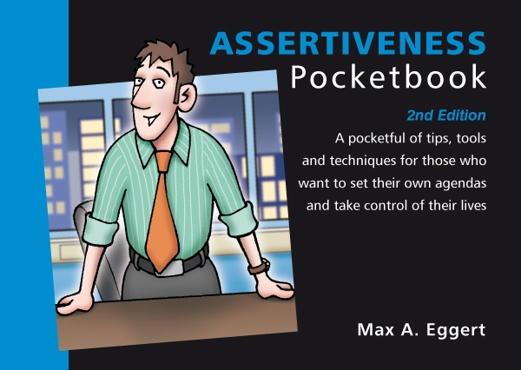
Assertiveness Quiz
Total Points : 100
Passing Score : 60%(60 points)

No | Questions |  | Points
1 | How do assertive people feel about receiving compliments?  ( ) They are comfortable with them and accept them with a smile  ( ) They discount them to avoid insulting the other person  ( ) They play them down for fear of appearing conceited  ( ) They are suspicious that the other person has a hidden agenda |  | 10 pts
2 | Assertiveness involves acting with integrity, honesty and directness. There is also another important aspect of assertiveness. Which one is it?  ( ) Respect for others  ( ) Tactfulness  ( ) Strength  ( ) Authority |  | 10 pts
3 | When an assertive person uses the technique known as 'negative assertion' what would they say to someone who accuses them of always making mistakes?  ( ) 'Yes, I do make mistakes occasionally'  ( ) 'What specifically are you thinking of?'  ( ) 'I think my record shows otherwise'  ( ) 'I'm sure you cannot prove it' |  | 10 pts
4 | Assertiveness requires you to match your body language with the words you use. Which of the following actions is that of an assertive person?  ( ) Maintains high eye contact  ( ) Speaks quietly and sometimes quickly  ( ) Often nods head in agreement  ( ) Raises hands above elbow level |  | 10 pts
5 | Self-defeating mind games (e.g. "I failed once therefore I will always fail") lead to non-assertive behaviour. The Assertiveness Pocketbook describes a number of such mind games. Among those listed below one is the action of an assertive person. Which one?  ( ) Mind reading  ( ) Affirmation  ( ) Generalisation  ( ) Personalising |  | 10 pts
6 | The following actions represent assertive behaviour, except for one. Which one is the exception?  ( ) Asking for what we want  ( ) Telling the truth and not having to pretend  ( ) Putting our personal needs before those of others  ( ) Saying 'no' when we don't want to do something |  | 10 pts
7 | As an assertive person how do you respond to criticism?  ( ) Immediately justify your behaviour  ( ) Remain quiet and hide your hurt  ( ) Ingratiate yourself with the other person  ( ) Understand it is inevitable and work through it |  | 10 pts
8 | When disagreeing with someone the assertive person doesn't get emotional, doesn't lose their integrity and doesn't lose their respect for the other person. The Assertiveness Pocketbook describes a five-step process for achieving this (there is a sixth optional step too). At what stage in the process do you strongly state your disagreement?  ( ) From the outset  ( ) Early on  ( ) Midway through  ( ) At the end |  | 10 pts
9 | Which of the following is the hallmark of an assertive person?  ( ) 'I' statements  ( ) 'We' statements  ( ) 'You' statements  ( ) 'One' statements |  | 10 pts
10 | All but one of the following ways in which to say 'no' characterise an assertive person. Which way is not assertive?  ( ) You just say 'no' without explanation  ( ) You say 'no' without making clear your feelings  ( ) You say 'no' and explain your reasons  ( ) You say 'no' and thank the person when appropriate |  | 10 pts

Answers
(Figures in brackets refer to the page numbers in the Pocketbook from where the questions are drawn.)
- They are comfortable with them and accept them with a smile (73)
- Respect for others (6)
- 'Yes, I do make mistakes occasionally' (92)
- Maintains high eye contact (65)
- Affirmation (23/39)
- Putting our personal needs before those of others (16)
- Understand it is inevitable and work through it (70)
- At the end (76)
- 'I' statements (82)
- You say 'no' and explain your reasons (97)

