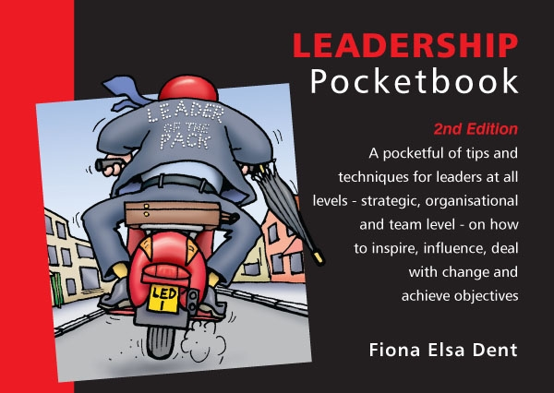
Leadership Quiz
Total Points : 100
Passing Score : 60%(60 points)

No | Questions | Points
1 | 'Authentic leaders' are true to themselves but in what way do they relate to other people?  ( ) Focused and challenging  ( ) Consistent and genuine  ( ) Goal- and action-oriented  ( ) Charismatic and sociable | 10 pts
2 | What distinguishes a leader from a manager?  ( ) They make all of the decisions, managers simply implement them  ( ) They take control of a situation while managers wait to be organised  ( ) They are recognised by others as providing leadership, managers are appointed leaders  ( ) They involve other people, whereas managers have other people reporting to them | 10 pts
3 | The Leadership Pocketbook describes a 'model for leadership'. At the heart of the model are four aspects of the leadership role that leaders need to carefully consider. They need to consider themselves (personality, values, etc), their job and their organisation. Which of the following is the fourth aspect?  ( ) The past and how this may affect the future  ( ) The wider world or broader social context  ( ) The financial climate and likely trends  ( ) The competitive environment and possible changes | 10 pts
4 | Of the following components of effective leadership one has been identified in recent research as key to success. Which one?  ( ) Clarity of goals and objectives  ( ) Skilled at keeping followers happy  ( ) Capable of being strong and resilient  ( ) Ability to vary style to suit the context | 10 pts
5 | Four typical styles of leadership are listed below. Which one is effective with inexperienced people yet ignores the need to motivate others?  ( ) Coaching  ( ) Influencing  ( ) Directive  ( ) Collaborative | 10 pts
6 | A leadership coach is someone who a leader can turn to in order to share problems and discuss confidential issues. The 'credentials' of such a coach are listed below. Which of them is the most important?  ( ) Can add value to leader's performance  ( ) Is someone liked by the leader  ( ) Is empathetic in dealings with leader  ( ) Engenders mutual trust and respect | 10 pts
7 | It goes without saying, leaders need followers. What do followers most expect their leader to be?  ( ) Energetic, appreciative and authentic  ( ) Powerful, strategic and decisive  ( ) Credible and knowledgeable  ( ) Authoritative and results-focused | 10 pts
8 | One of the key qualities of successful leadership is 'vision'. Which of the following actions does the visionary leader find the most challenging?  ( ) Generating ideas about the way ahead (the vision)  ( ) Questioning what the vision will look and feel like  ( ) Articulating the vision to gain buy-in and understanding  ( ) Identifying actionable steps to achieve the vision | 10 pts
9 | Leaders must be able to master the art of influencing. Which of the following is critical to this process?  ( ) The ability to get a point across clearly  ( ) Understanding/accommodating others' views  ( ) Appearing self-confident and having courage  ( ) Demonstrating both enthusiasm and patience | 10 pts
10 | What is the first main challenge for any leader who is attempting to create a change mindset in their colleagues  ( ) Raise awareness of the necessity for the change  ( ) Get key stakeholders and other influencers on board  ( ) Agree a process for implementing the change  ( ) Provide the parameters for change | 10 pts

Answers
(Figures in brackets refer to the page numbers in the Pocketbook from where the questions are drawn.)
- Consistent and genuine (9)
- They are recognised by others as providing leadership, managers are appointed leaders (20)
- The wider world or broader social context (23)
- Ability to vary style to suit the context (42)
- Directive (45)
- Engenders mutual trust and respect (52)
- Energetic, appreciative and authentic (59)
- Articulating the vision to gain buy-in and understanding (74)
- Understanding/accommodating others' views (80-83)
- Get key stakeholders and other influencers on board (93)

