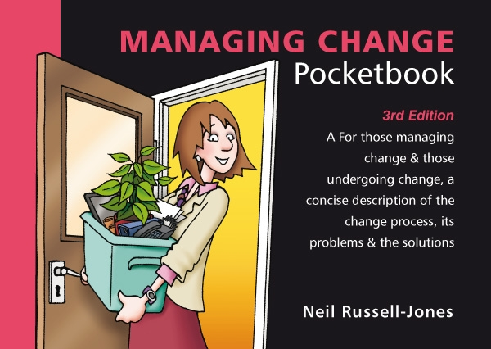
Managing Change Quiz
Total Points : 100
Passing Score : 60%(60 points)

No | Questions | Points
1 | Which of the following is not a driver of change?  ( ) Increasing competition.  ( ) Mergers and acquisitions.  ( ) Satisfaction with the current situation.  ( ) New or amended regulation. | 10 pts
2 | Generally speaking, how do organisations tend to deal with change?  ( ) Regularly transforming their accepted practices to stay agile and ensure survival.  ( ) Changing their core policies and processes in response to change as it occurs.  ( ) Only changing when there is a serious threat to the business or an industry-wide transformation.  ( ) Reviewing change constantly to plan the best time to make reactive and proactive adjustments. | 10 pts
3 | What is essential for every successful change management programme?  ( ) Commitment from everyone.  ( ) Buy-in from senior management.  ( ) A clear written strategy.  ( ) A strong company culture. | 10 pts
4 | Beckhard outlined seven conditions for successful change. Which of the following is not among them?  ( ) Rigid organisational structures.  ( ) Understanding of external relationships.  ( ) Effective use of technology.  ( ) Organisational vision. | 10 pts
5 | How should changes be made?  ( ) As a clearly visible break from old practices.  ( ) Sticking as closely to the old ways as possible.  ( ) Without ever disturbing any established processes.  ( ) Without consideration for established processes. | 10 pts
6 | What is the biggest barrier to change?  ( ) Insufficient skills.  ( ) Inappropriate culture.  ( ) Incomplete follow-up.  ( ) Employee resistance. | 10 pts
7 | How can you approach change in an organisation with a task culture?  ( ) Work your way up the management structure, securing support as you go.  ( ) Take key decision makers with you and secure buy-in from most people.  ( ) Secure support for the change, and endorsement, from the central leader.  ( ) Incorporate change management processes into every task group meeting. | 10 pts
8 | Which of the following is not considered during the analysis phase of the change management framework?  ( ) The champion for the change initiative.  ( ) The organisation's ability to absorb change.  ( ) The culture of the organisation.  ( ) The nature of the change required. | 10 pts
9 | How do you tackle those who oppose change and the change management team personally?  ( ) Keep them on side.  ( ) Marginalise them.  ( ) Win them over.  ( ) Listen to them. | 10 pts
10 | Who should control the communication process around change?  ( ) A mid-level manager in close contact with those affected.  ( ) The corporate communications and public relations team.  ( ) Sponsoring executive, or CEO in a big company.  ( ) The personnel who are directly affected by the change. | 10 pts

Answers
(Figures in brackets refer to the page numbers in the Pocketbook from where the questions are drawn.)
- Satisfaction with the current situation. (18)
- Only changing when there is a serious threat to the business or an industry-wide transformation. (20)
- Commitment from everyone. (27)
- Rigid organisational structures. (32)
- Sticking as closely to the old ways as possible. (37)
- Employee resistance. (43)
- Take key decision makers with you and secure buy-in from most people. (51)
- The champion for the change initiative. (72)
- Marginalise them. (91)
- Sponsoring executive, or CEO in a big company. (102)

