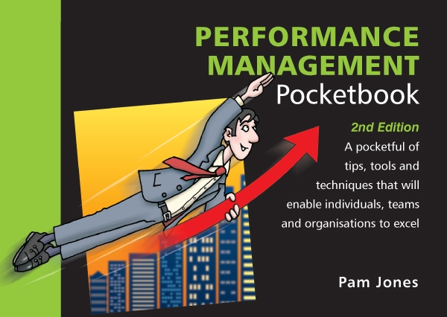
Performance Management Quiz
Total Points : 100
Passing Score : 60%(60 points)

No | Questions | Points
1 | What is performance management?  ( ) A process for tackling poor performance in the workplace.  ( ) The pay and rewards process adopted in the organisation.  ( ) A structured and documented means of measuring and managing performance.  ( ) An approach to achieving a shared vision of the purpose and aims of the organisation. | 10 pts
2 | Why is engagement so important in organisations?  ( ) It helps to develop people.  ( ) Organisations like to measure it in annual surveys.  ( ) It helps everyone to be motivated.  ( ) It influences bottom line performance. | 10 pts
3 | Why is it useful to focus on individual strengths?  ( ) It means people more readily accept their weaknesses.  ( ) It saves having to focus on the things people are not good at.  ( ) It helps in preparing for interviews.  ( ) Helps people to perform to their potential. | 10 pts
4 | When delegating what is the first thing you should do?  ( ) Plan what to do with the free time this affords.  ( ) Identify exactly what needs to be done.  ( ) Decide what element of your job you can delegate.  ( ) Set a completion date for the delegated task. | 10 pts
5 | What is the aim of coaching?  ( ) To help people come up with their own solutions.  ( ) To transfer essential knowledge to others.  ( ) To get things done more quickly and efficiently.  ( ) To teach people to do something new. | 10 pts
6 | When giving feedback to other people what do you need to do?  ( ) Keep the feedback balanced.  ( ) Get straight to the point.  ( ) Focus on the individual.  ( ) Not accept excuses. | 10 pts
7 | When tackling poor performance what should you do?  ( ) Report the issue immediately to the HR department.  ( ) Request a private meeting and reprimand the individual.  ( ) Delay dealing with it until the annual appraisal meeting.  ( ) Try to understand why the situation has happened. | 10 pts
8 | What do you think is the most important factor in motivating others?  ( ) Challenging and interesting work.  ( ) Job title and position.  ( ) Money and bonuses.  ( ) Training and development. | 10 pts
9 | When you are setting objectives what do you do?  ( ) Identify the tasks which need to be completed.  ( ) Focus on outcomes and deliverables.  ( ) Set them each year at the appraisal meeting.  ( ) Make sure they are linked to the bonus scheme. | 10 pts
10 | What do high performing teams do?  ( ) Go out together on a regular basis (promotes teamworking).  ( ) Try to get the task achieved as quickly as possible.  ( ) Avoid conflict and instead focus on performance outcomes.  ( ) Understand each other and appreciate differences. | 10 pts

Answers
(Figures in brackets refer to the page numbers in the Pocketbook from where the questions are drawn.)
- An approach to achieving a shared vision of the purpose and aims of the organisation. (7)
- It influences bottom line performance. (11)
- Helps people to perform to their potential. (26)
- Decide what element of your job you can delegate. (6)
- To help people come up with their own solutions. (41)
- Keep the feedback balanced. (52)
- Try to understand why the situation has happened. (57)
- Challenging and interesting work. (65)
- Focus on outcomes and deliverables. (73)
- Understand each other and appreciate differences. (92)

