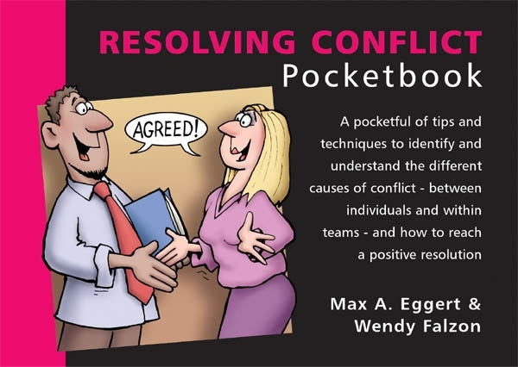
Resolving Conflict Quiz
Total Points : 100
Passing Score : 60%(60 points)

No | Questions | Points
1 | In conflict resolution, which outcome should you work towards?  ( ) I win, you lose.  ( ) You win, I lose.  ( ) You win, I win.  ( ) I lose, you lose. | 10 pts
2 | Which of the following is not likely to result in the need for conflict resolution?  ( ) Overcrowding in the office.  ( ) Poor communication skills.  ( ) Differences between teams.  ( ) Abundance of resources. | 10 pts
3 | Which is the best conflict resolution strategy if you want to achieve a win/win outcome?  ( ) Capitulation.  ( ) Collaboration.  ( ) Domination.  ( ) Negotiation.  ( ) Procrastination. | 10 pts
4 | When you reach a settlement that is within the 'agreement box', what is the outcome?  ( ) You get exactly what you want.  ( ) You make some concessions.  ( ) The other party gets exactly what they want.  ( ) You both get exactly what you want. | 10 pts
5 | If the other party offers you two options and one of them is completely unacceptable to you, what are they trying to do?  ( ) Bring the discussion to an end.  ( ) Force you to follow their agenda.  ( ) Weaken your case against them.  ( ) Intimidate you into settling. | 10 pts
6 | When you use the BATNA process in assessing an offer, what should you compare a proposal against?  ( ) What will happen if you can't reach agreement.  ( ) The best possible outcome of the agreement.  ( ) The worst possible outcome of the agreement.  ( ) How other parties feel about other proposals. | 10 pts
7 | When is arbitration an inappropriate way to resolve a conflict?  ( ) When the dispute concerns facts.  ( ) When the dispute concerns emotions.  ( ) When the dispute concerns the law.  ( ) When the dispute concerns a contract.  ( ) When the parties cannot cooperate. | 10 pts
8 | When a manager acts as a mediator, what should he or she do?  ( ) Take the "right" side in the dispute.  ( ) Disregard the cost of someone changing their position.  ( ) Suspend judgement for as long as possible.  ( ) Disregard the egos of those in the dispute. | 10 pts
9 | Which of the following strategies will not reduce conflict at work?  ( ) Holding everyone accountable to the same values.  ( ) Having an active open door policy for managers.  ( ) Articulating a clear vision and mission statement.  ( ) Offering the best pay package in the market. | 10 pts
10 | Which of the following behaviours might constitute harassment?  ( ) Asking one of your colleagues out on a date.  ( ) Going for lunch with half of your team.  ( ) Seeing work friends outside of work.  ( ) Unintentionally causing offense with a sexual remark. | 10 pts

Answers
(Figures in brackets refer to the page numbers in the Pocketbook from where the questions are drawn.)
- You win, I win. (11)
- Abundance of resources. (12-13)
- Collaboration. (18-20)
- You make some concessions. (33)
- Weaken your case against them. (36-42)
- What will happen if you can't reach agreement. (46)
- When the dispute concerns emotions. (75)
- Suspend judgement for as long as possible. (79)
- Offering the best pay package in the market. (88)
- Unintentionally causing offense with a sexual remark. (108)

