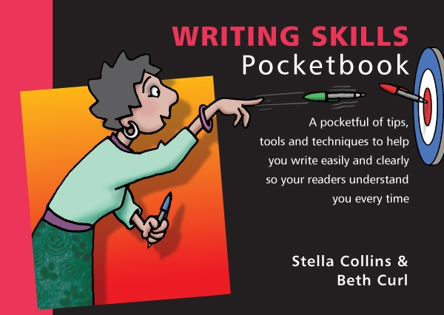
Writing Skills Quiz
Total Points : 100
Passing Score : 60%(60 points)
No | Questions |  | Points
1 | You have a reasonably lengthy document to write. What is the first question you need to ask yourself? Is it:  ( ) What style of language should I adopt?  ( ) How will I word the introductory statement?  ( ) What is the purpose of my writing?  ( ) What typeface should I choose?  ( ) How many pages should I write? |  | 10 pts
2 | Which structure is the ‘active’ construction:  ( ) Target, verb, agent?  ( ) Agent, verb, target?  ( ) Verb, target, agent? |  | 10 pts
3 | Having drafted your document, set it aside and then returned to it, do you:  ( ) Critique then proofread it?  ( ) Proofread then critique it?  ( ) Don't do either because you've already spell-checked? |  | 10 pts
4 | Where should you put your key message?  ( ) At the beginning of the sentence/paragraph/document.  ( ) In the middle of your document so you can build up to it.  ( ) At the end of the sentence/paragraph/document so it has lasting impact. |  | 10 pts
5 | Which of these sentences is most likely to get someone to back up the computer?  ( ) Don't forget to back up the computer before you turn it off.  ( ) Never turn off the computer until you have backed it up.  ( ) Remember to back up the computer and then turn it off. |  | 10 pts
6 | Your reader has agreed to take action but not yet done so. How do you respond?  ( ) State what was agreed, state it hasn't happened yet and get information to plan the way forward.  ( ) Take a blunt, threatening approach to provoke immediate action.  ( ) Take a soft approach, indicating that you may not have made yourself clear.  ( ) You don't respond, preferring to keep quiet in the hope they will eventually take action. |  | 10 pts
7 | To make your writing a pleasure to read, is it better to:  ( ) Write in the impersonal and passive styles?  ( ) Use jargon and nominalizations wherever possible?  ( ) Add long compound nouns to better illustrate your point?  ( ) Use simple words and short sentences?  ( ) Frequently introduce clauses to provide detail? |  | 10 pts
8 | In which of these sentences are the apostrophes in the correct place?  ( ) It’s my cat and its’ fur is black.  ( ) It’s my cat and its fur is black.  ( ) Its’ my cat and its’ fur is black. |  | 10 pts
9 | What does a ‘statement of purpose’ include?  ( ) The title of your document and a list of topics to be covered.  ( ) A list of your readers and details of what is of real interest to them.  ( ) What you want to achieve, what you want the reader to do and when. |  | 10 pts
10 | How is a nominalization (verb turned into a noun) characterized? By:  ( ) Words ending in ‘ed’ or ‘er’?  ( ) Words ending in ‘ing’, ‘ment’, ‘tion’?  ( ) Short and simple sentences?  ( ) Passive rather than active verbs?  ( ) Use of quotation marks? |  | 10 pts

Answers
(Figures in brackets refer to the page numbers in the Pocketbook from where the questions are drawn.)
- What is the purpose of my writing? (14)
- Agent, verb, target? (50)
- Critique then proofread it? (73)
- At the beginning of the sentence/paragraph/document. (29)
- Remember to back up the computer and then turn it off. (96)
- State what was agreed, state it hasn't happened yet and get information to plan the way forward. (89)
- Use simple words and short sentences? (39)
- It’s my cat and its fur is black. (57)
- What you want to achieve, what you want the reader to do and when. (16)
- Words ending in ‘ing’, ‘ment’, ‘tion’? (52)

